**DSC 423: Data Analysis and Regression Assignment 05**

**Saransh Thakur**

**Id: 2020070**

**Problem1**

Cross-validation is a resampling procedure used to model a data sample. We use cross-validation so that our model works well for future or unseen data. It has a single parameter k, which tells the number of groups into which the data sample is split. The rule of thumb is to take k=10

We randomly divide the data into k equal folds to select a final model using cross-validation. Now each fold is treated as a validation set and we train our model on that. We do that for each fold for k iteration and at last, we take the average for that. It gives us unbiased results.

**Example: -**

In the below example, I have divided my data into 4 equal folds /parts where k=4

Now, each fold is treated as a validation set and we train our model on that. At last, we take the average of the result.

We do that for each fold, in this case, we repeat that 4 times and every time we average the result.

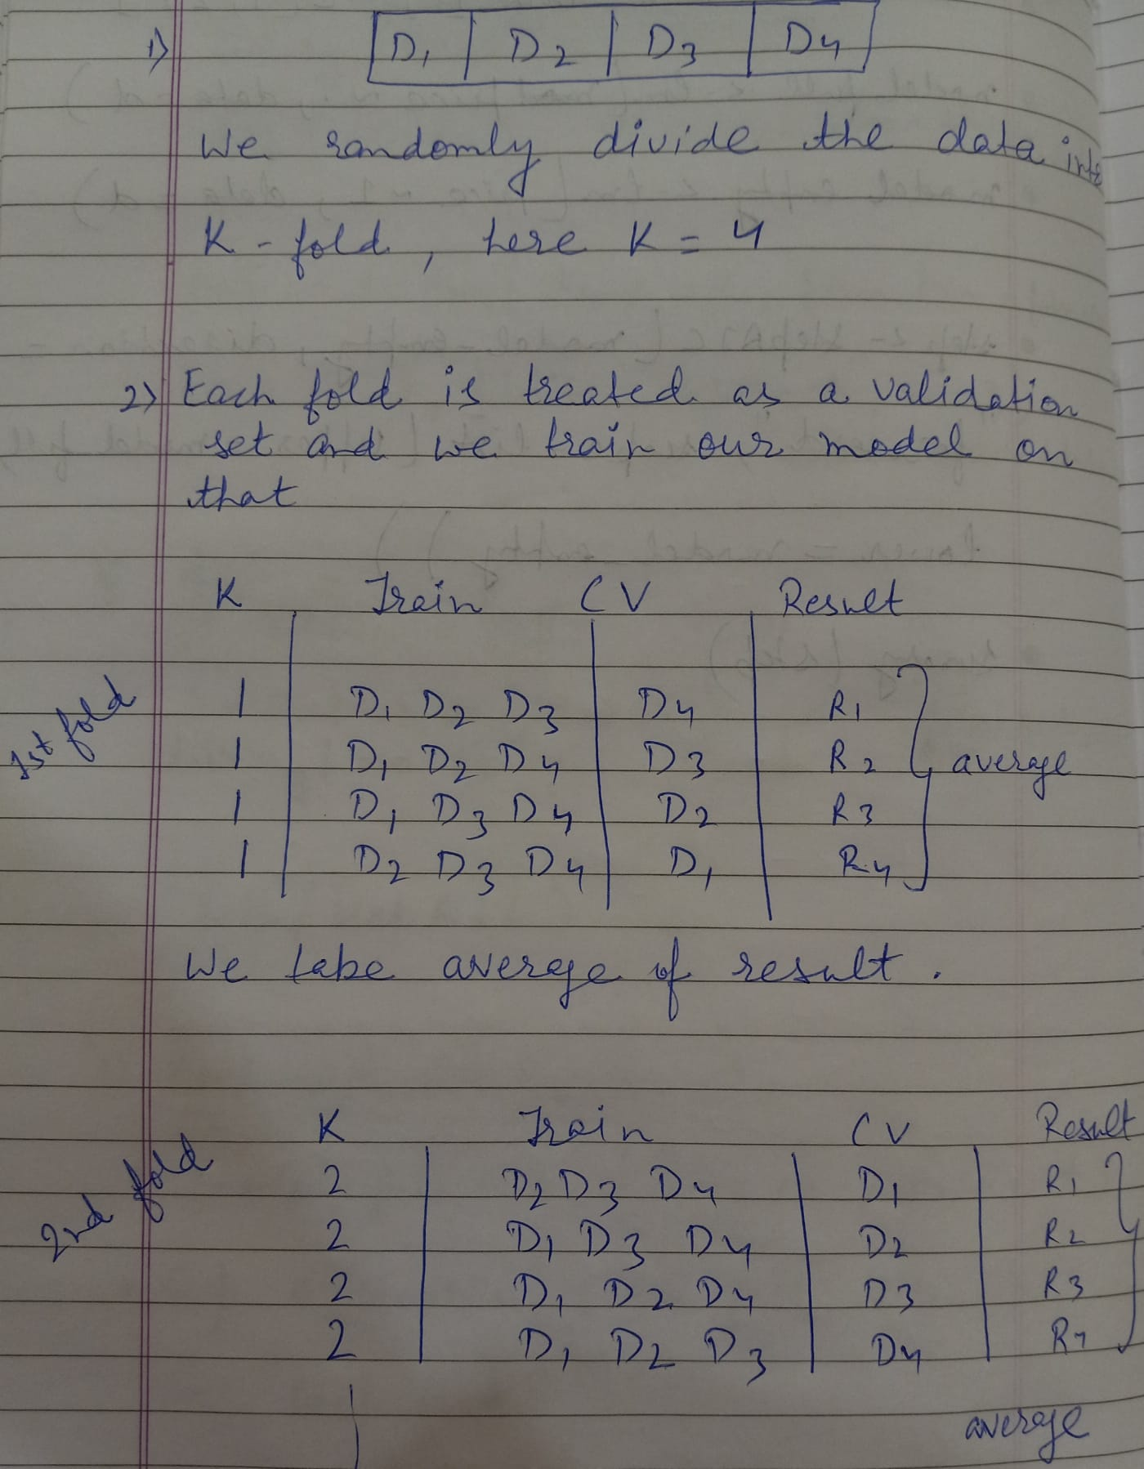

**Problem 2**

1. **First-order model**

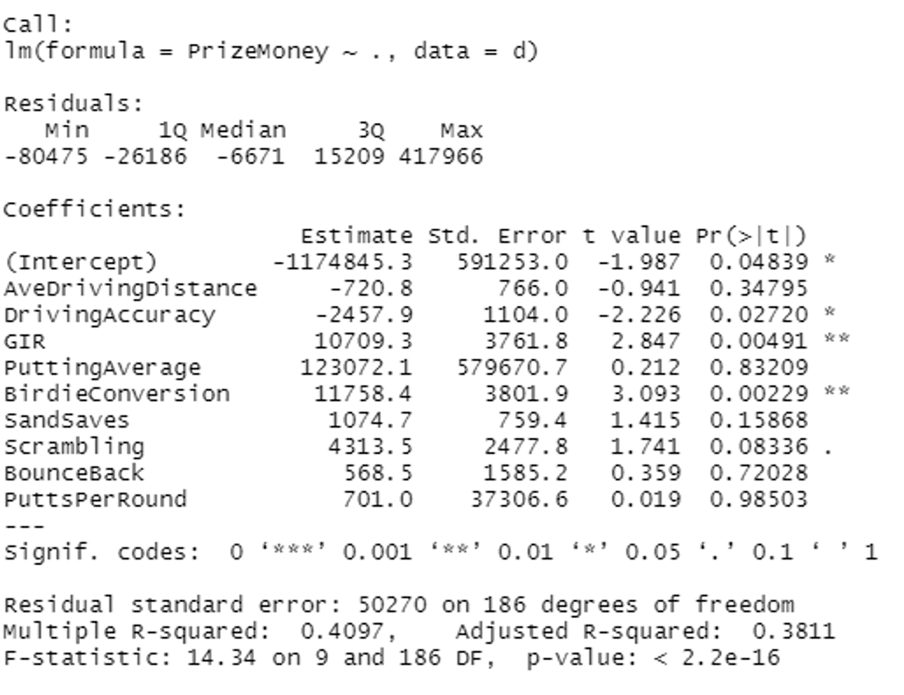

F-test has a very low P-value, this means that we reject the null hypothesis i.e. (all the Betas are equal to zero) and accept the alternative hypothesis that at least one is not equal to zero.

It tells us that something in the model is working.

For, driving accuracy, Gir, and birdie conversion we reject the null hypothesis and accept the alternative hypothesis, they all lie under the significance value of 0.05.

The adjusted R-squared is 0.3811which means 38.11% variability in y is explained by our model.

**5-fold cross-validation**

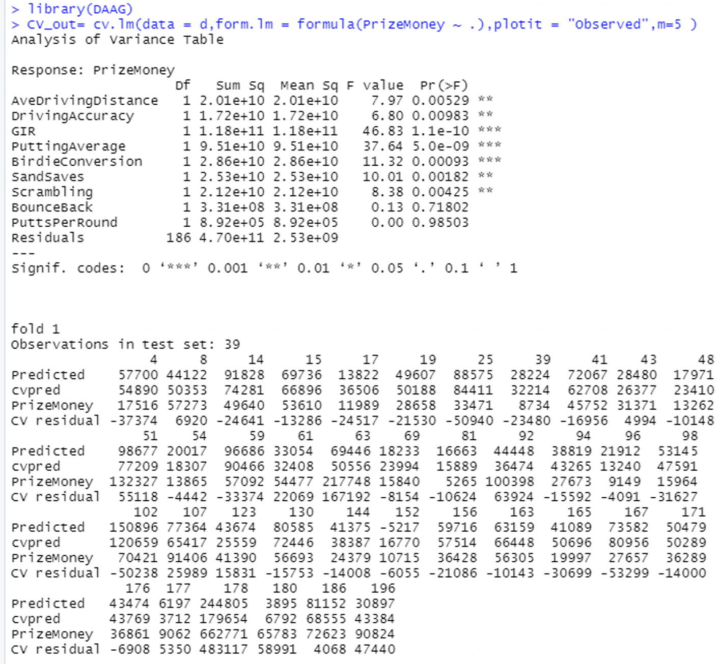

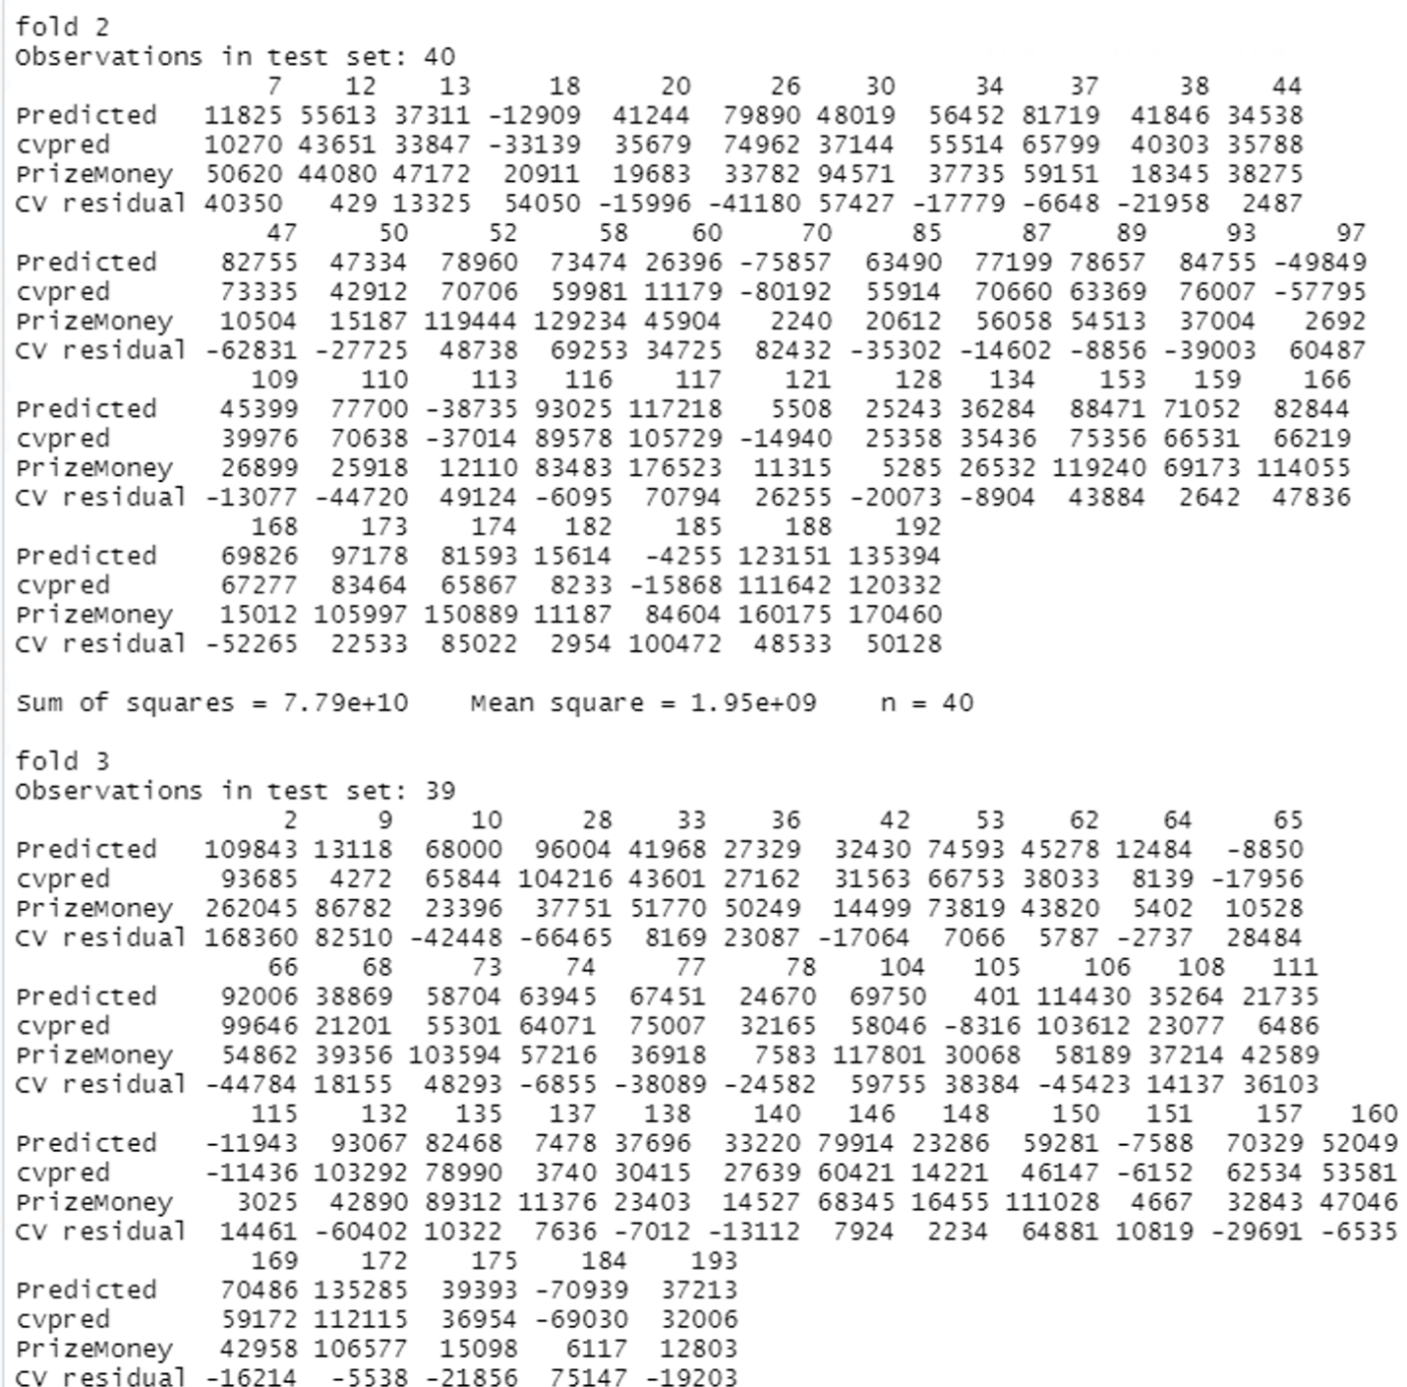

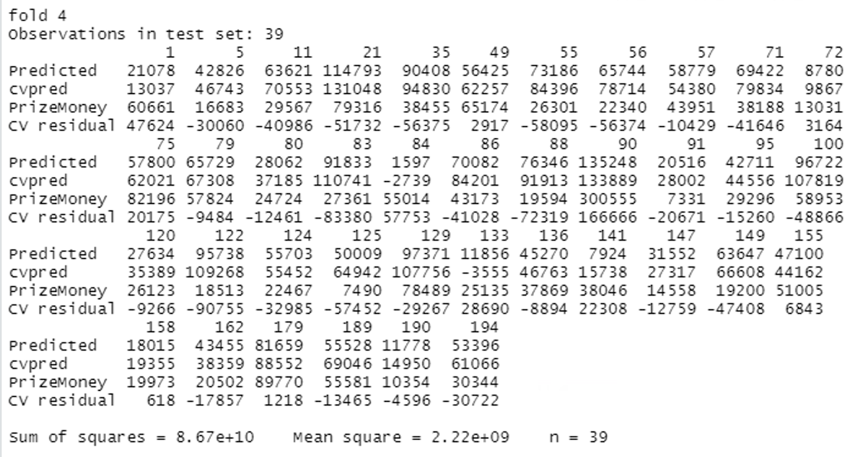

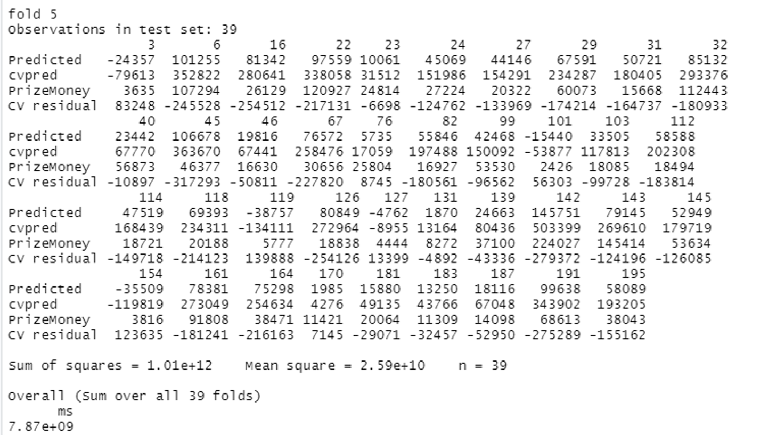

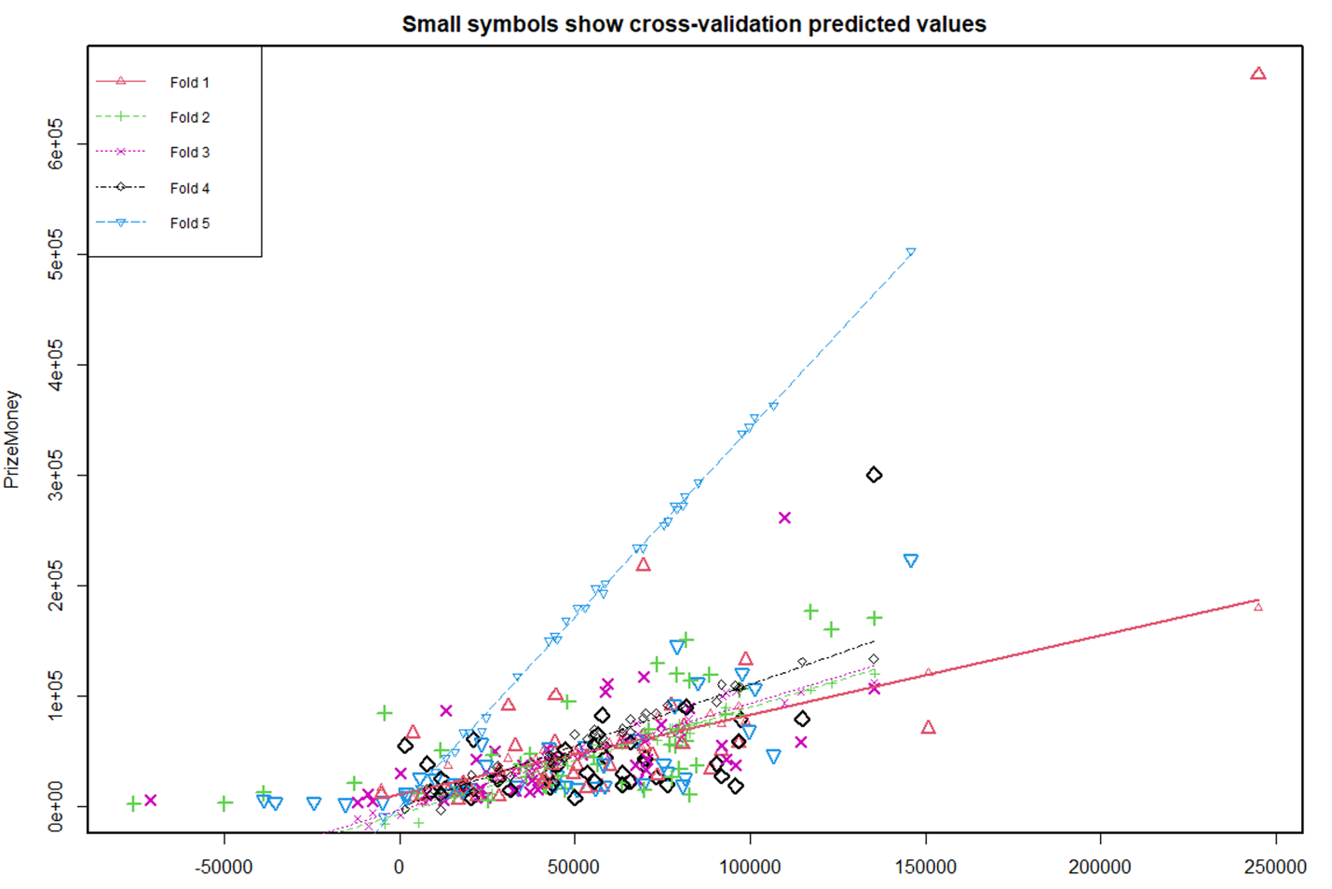

The average mean square error for 5-fold cross-validation is **7.87e+09**

**Final model: -**

To get the final model I remove the variable with the worst p-value, so after removing the non-significance variable the final model is

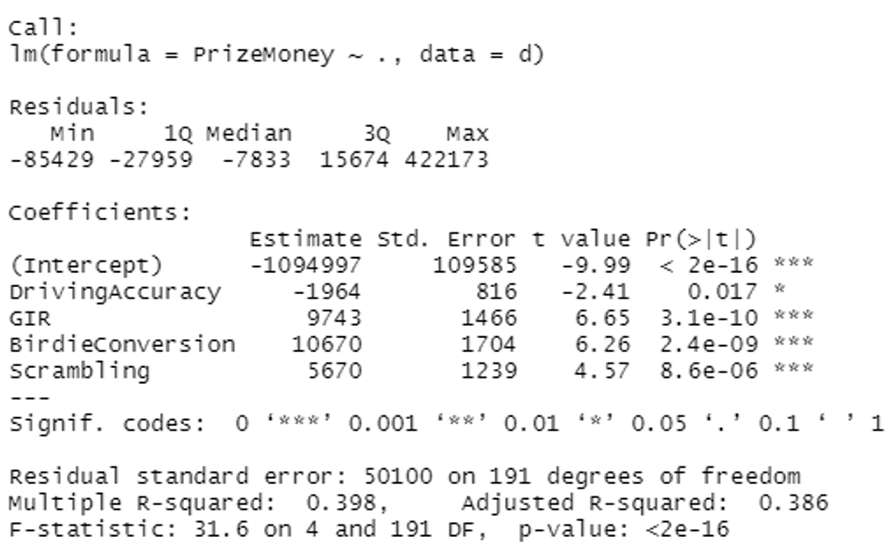

For, the final model, the F test has a p-value under a significant value of 0.05 so we fail to reject the null hypothesis and accept the alternative hypothesis that at least one Beta is not equal to zero. Then, for the t-test, all the variable lies under the significance value of 0.05 and the adjusted R-squared is 38.6 % which means that 38.6% of the variability in y is explained by our model.

**5-fold cross-validation on the final model.**

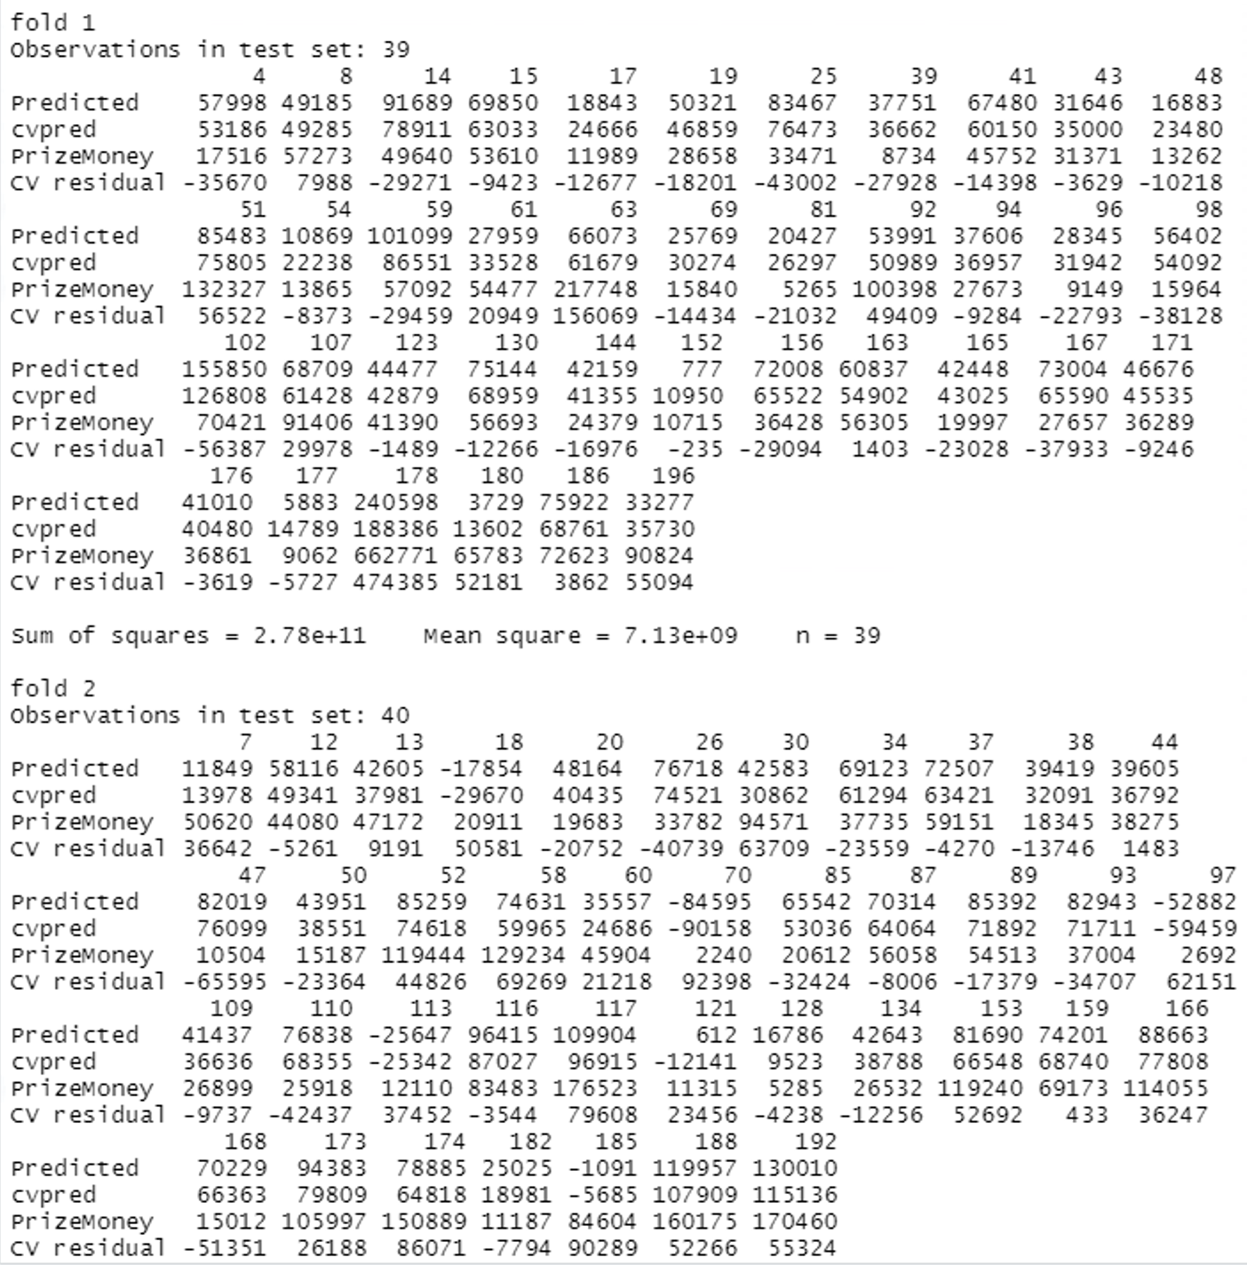

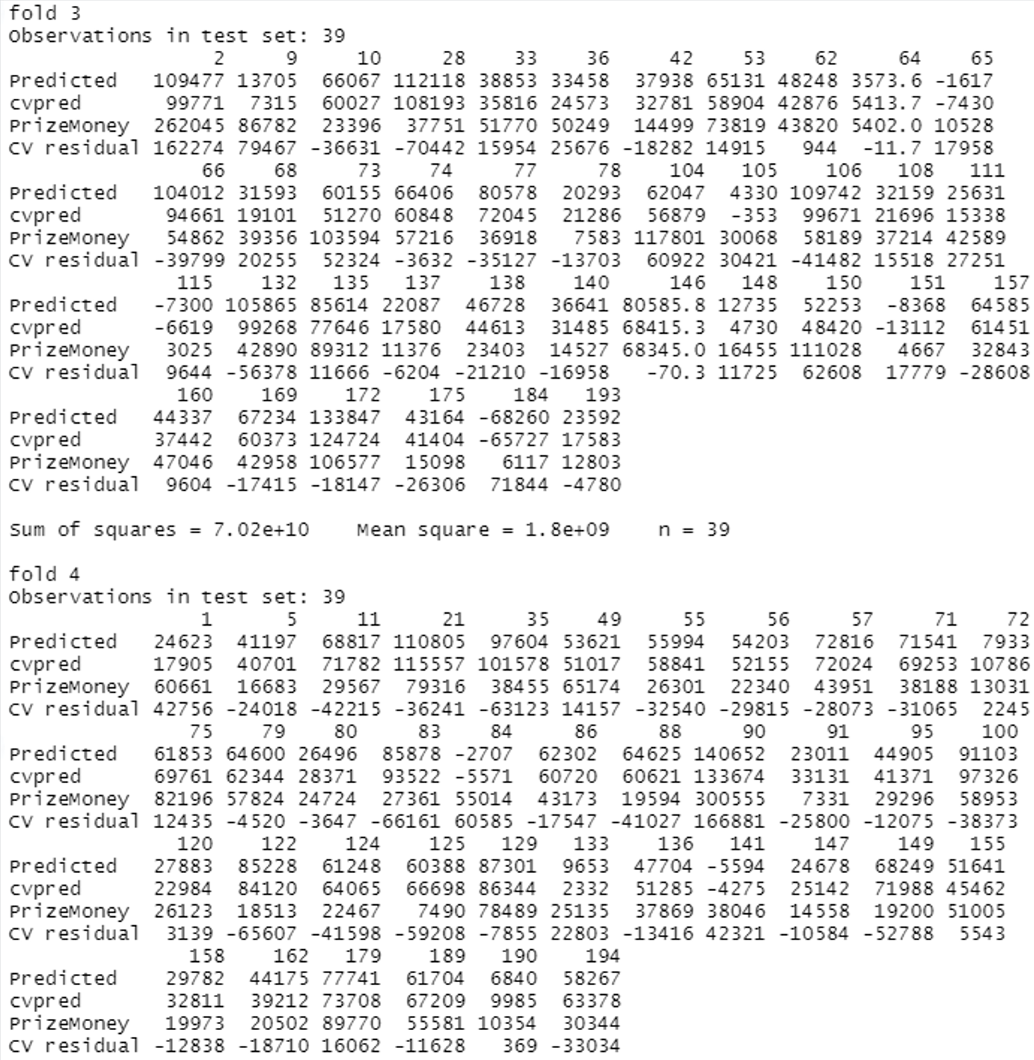

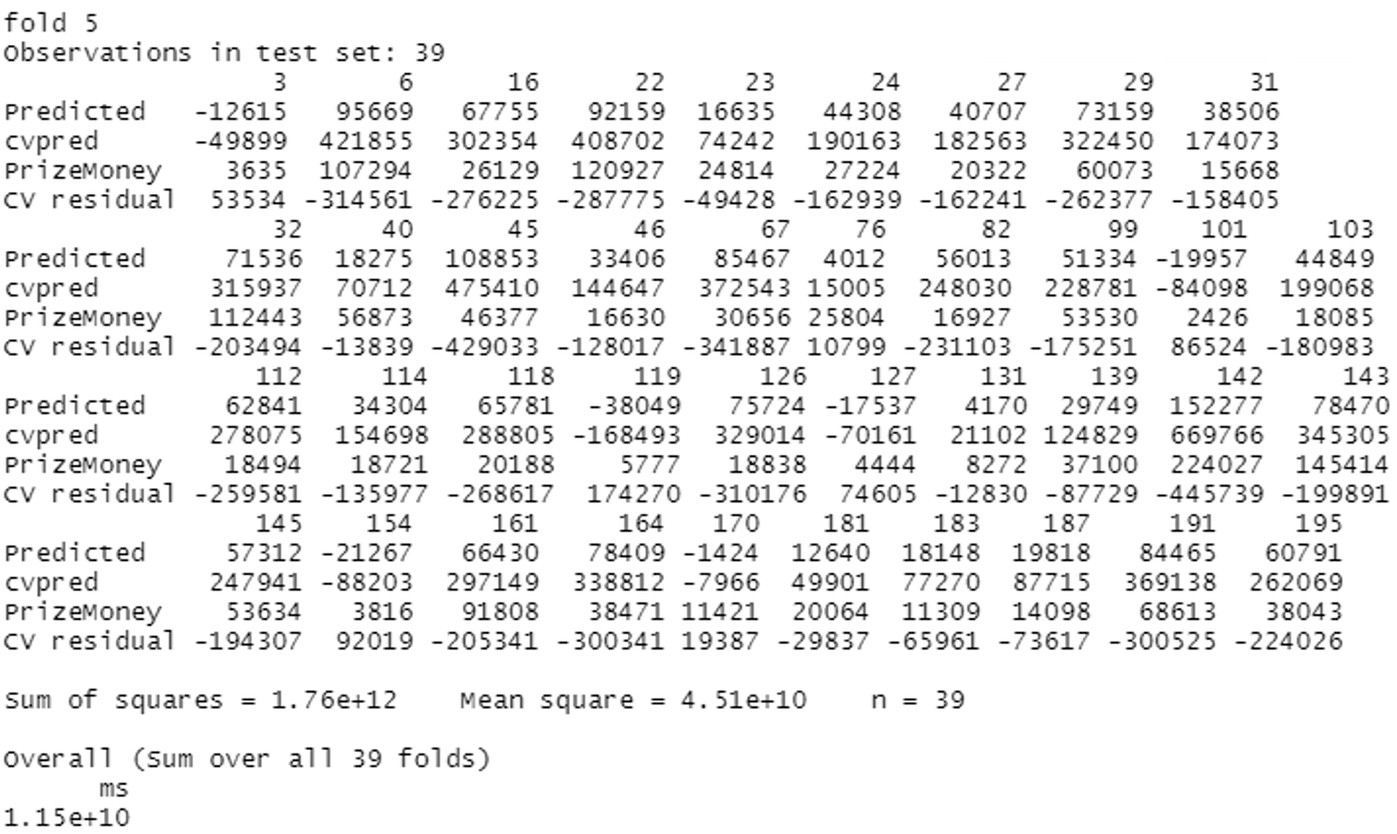

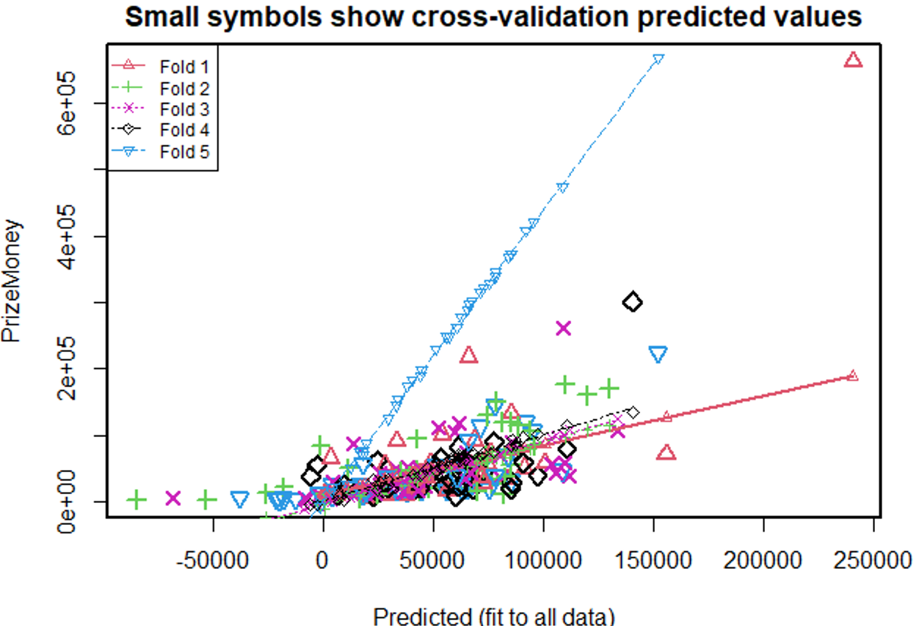

The average mean square error for 5-fold cross-validation is 1.15e+10

1. From scatterplots, the second-order terms which should be tested are Gir, Birdie Conversion, and bounce back.

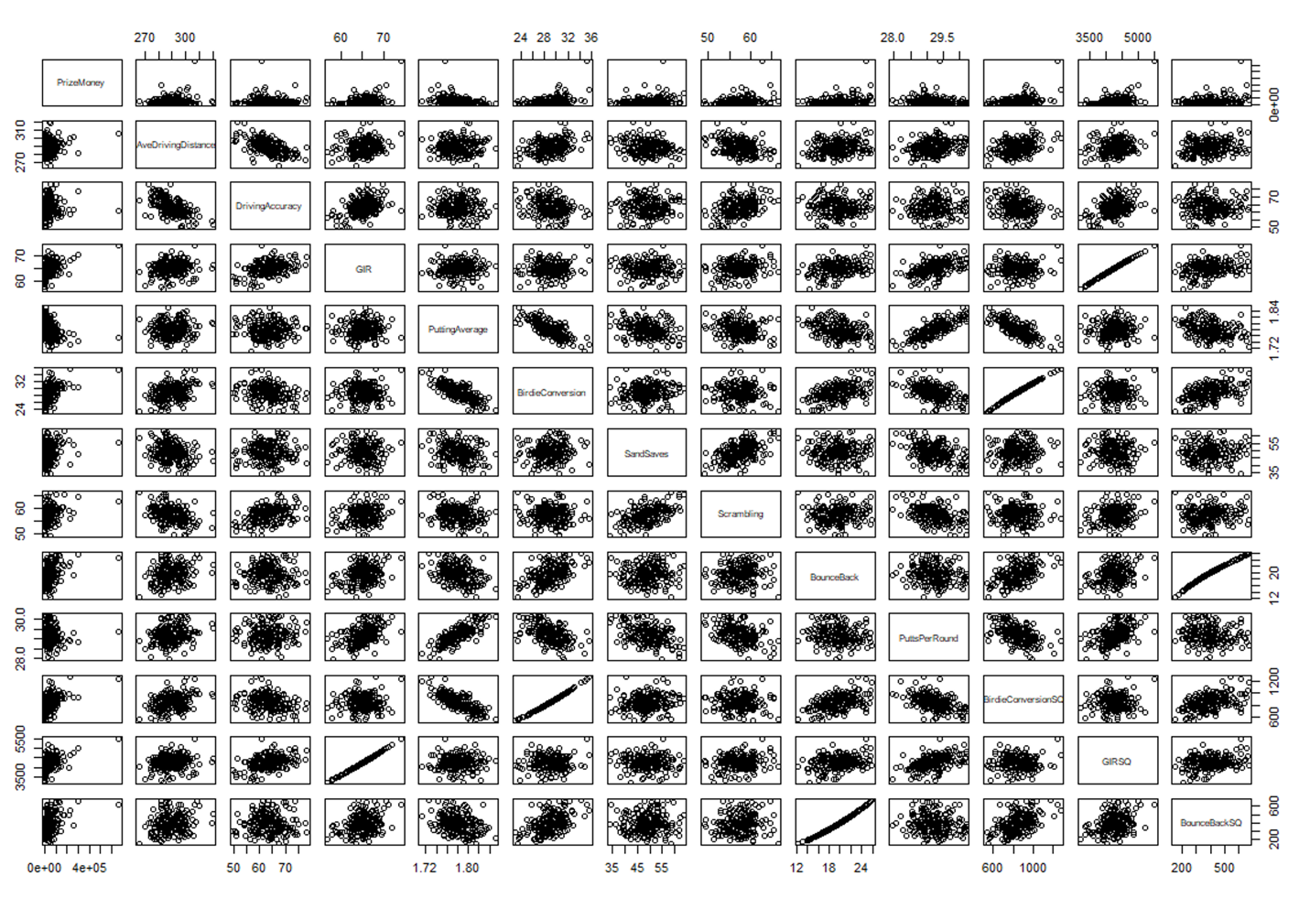

Adding **GIRSQ** to our model and evaluating 5-fold cross-validation

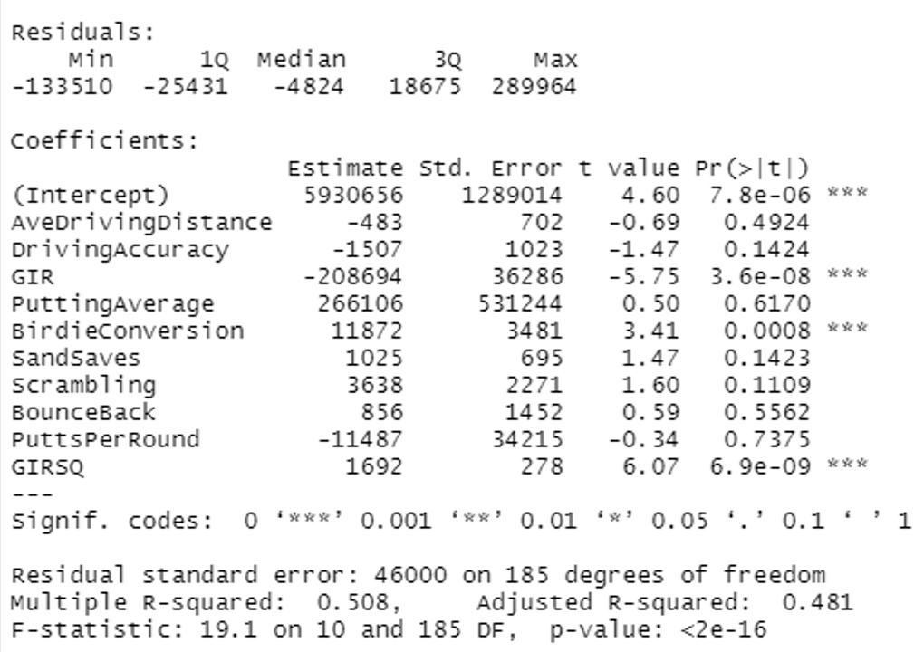

After adding **GIRSQ** F-test has a very low P-value, this means that we reject the null hypothesis i.e. (all the Betas are equal to zero) and accept the alternative hypothesis that at least one is not equal to zero.

For Gir, birdie conversion, AND GIRSQ we reject the null hypothesis and accept the alternative hypothesis, they all lie under the significance value of 0.05.

The adjusted R-squared is 0.481, meaning 48.1% variability in y is explained by our model.

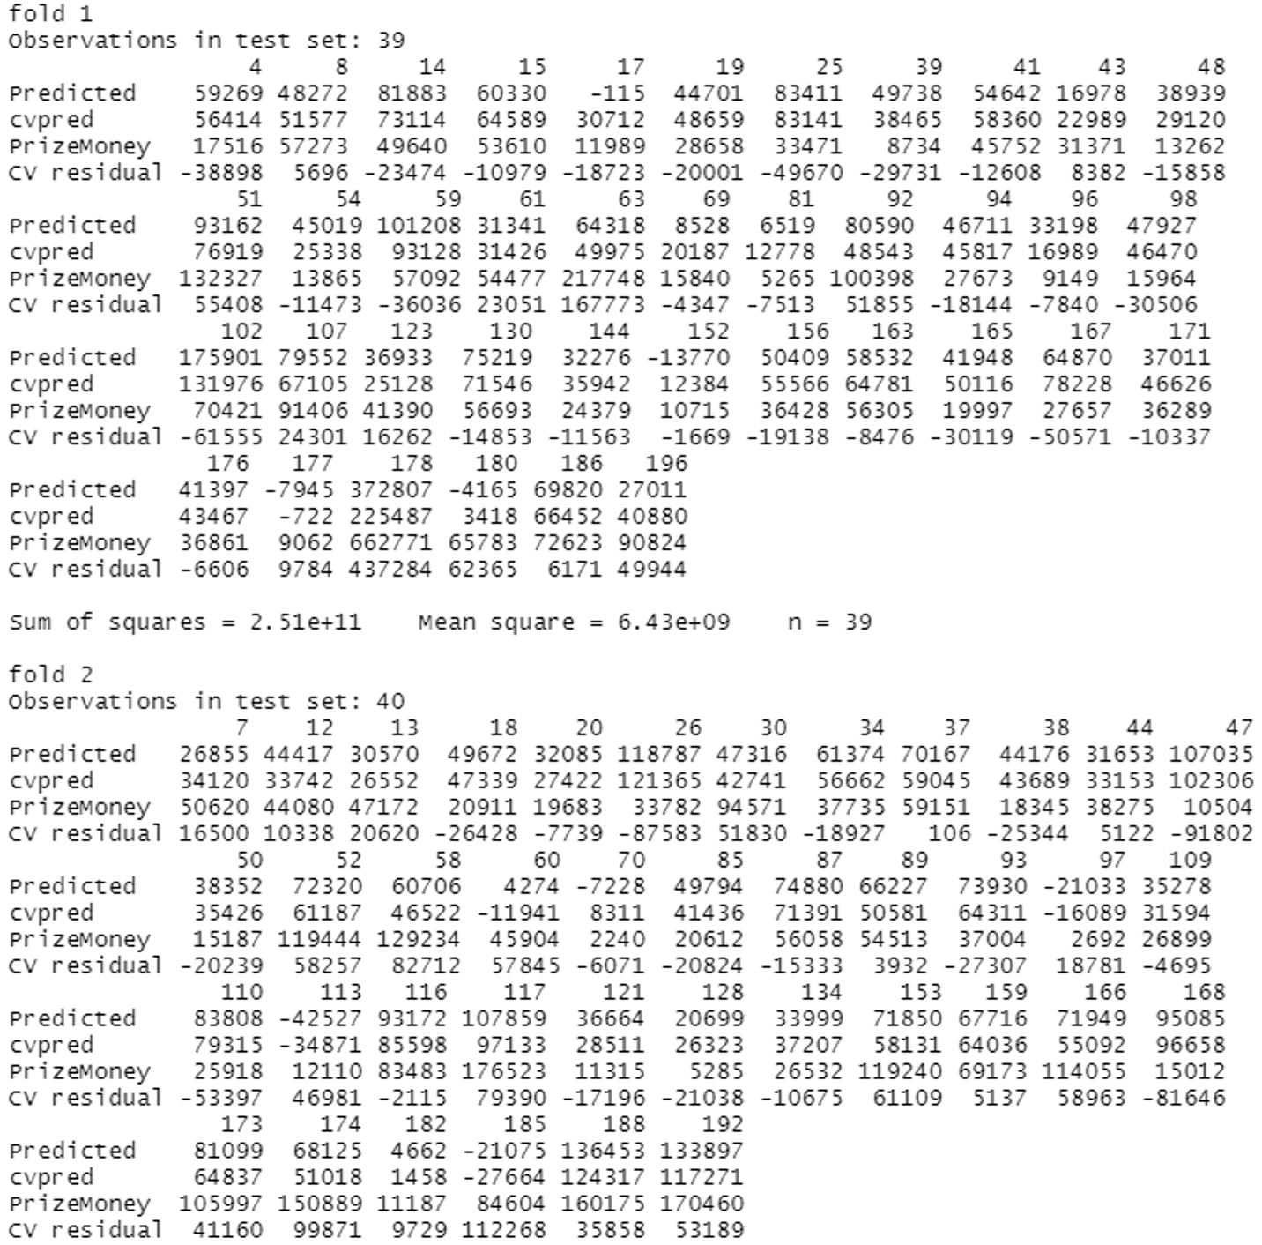

5-fold cross-validation after adding GIRSQ

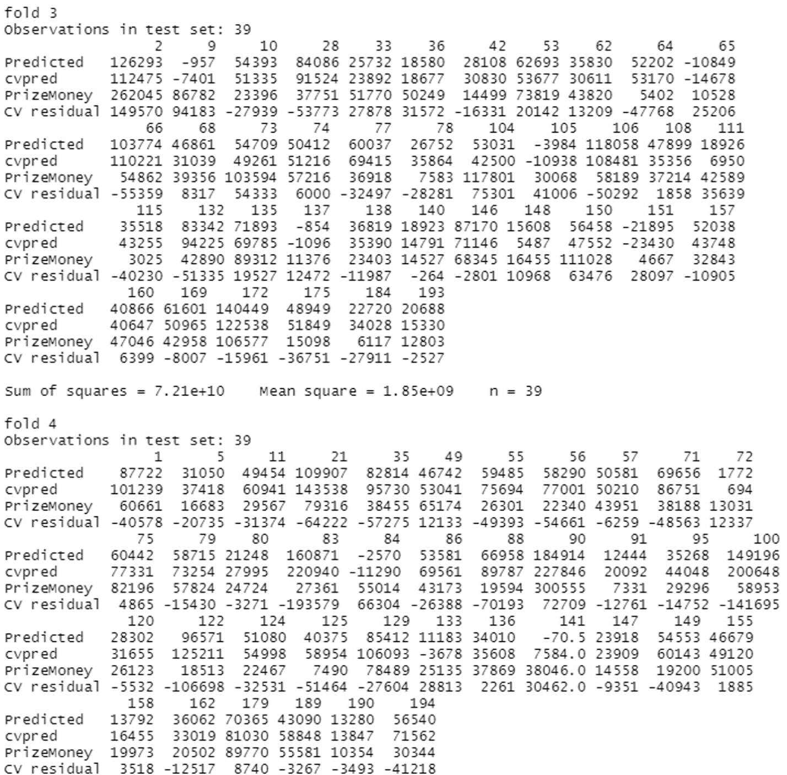

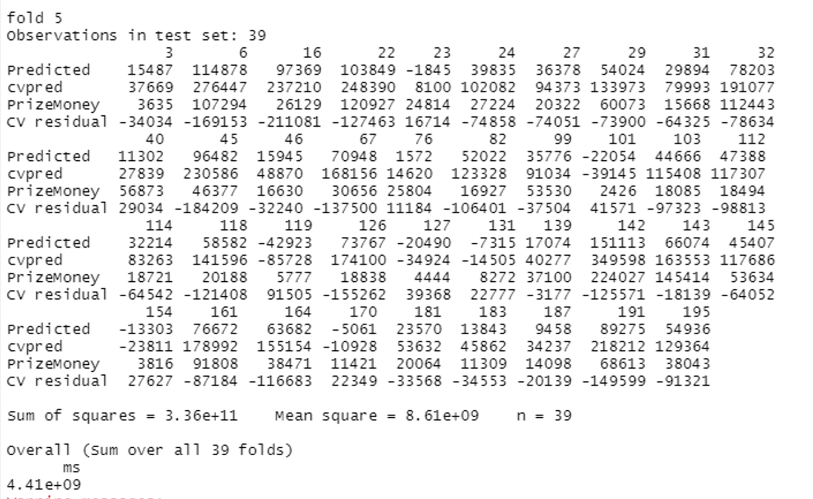

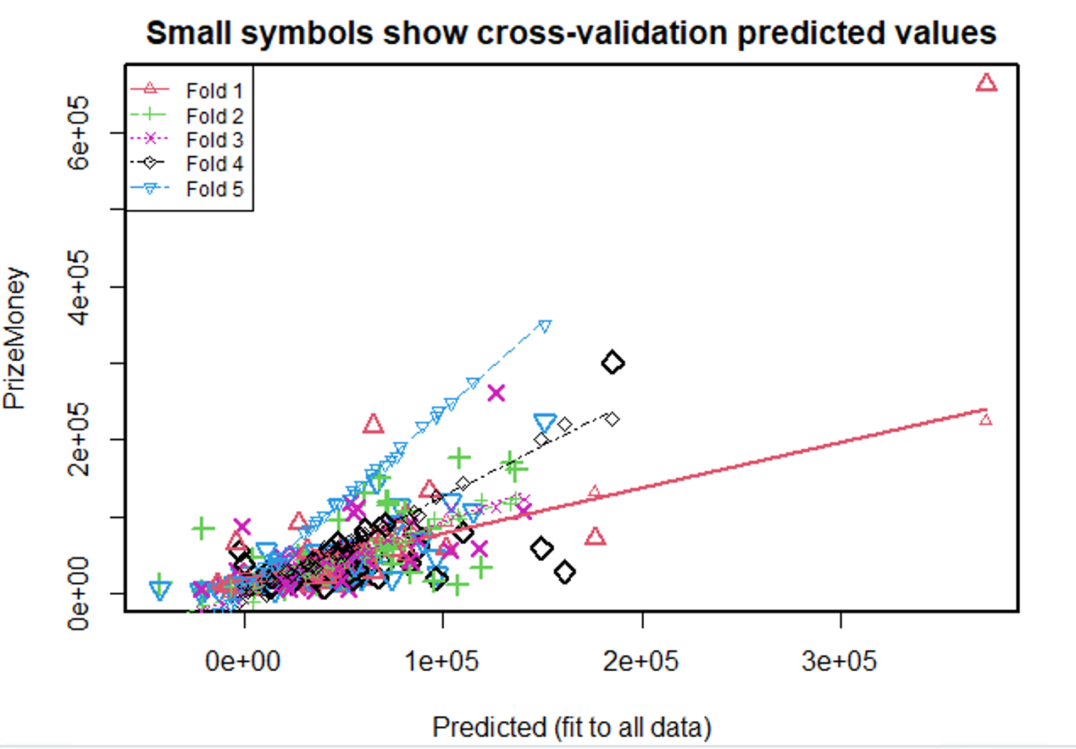

The average mean square error for 5-fold cross-validation after adding GIRSQ is **4.41e+09**

Now, adding **GIRSQ, BirdieConversionSQ** to our model and evaluating 5-fold cross-validation

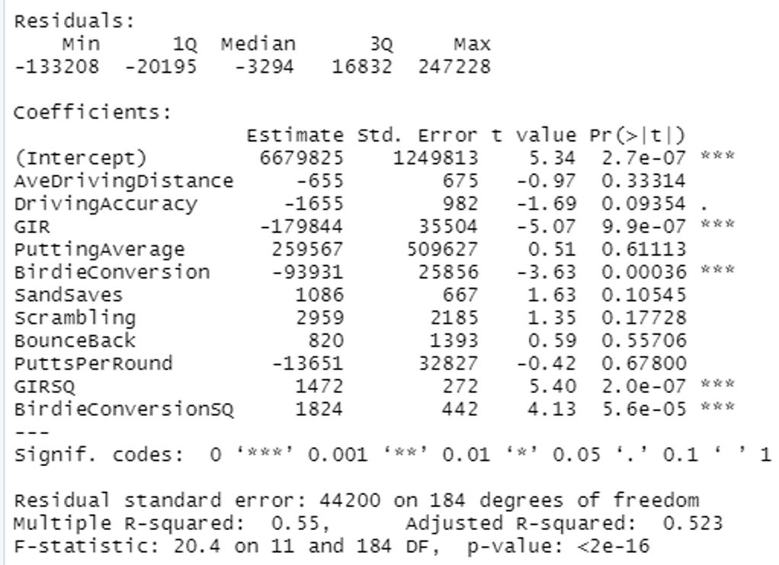

After adding **BirdieConversionSQ,** F-test has a very low P-value, this means that we reject the null hypothesis i.e. (all the Betas are equal to zero), and accept the alternative hypothesis that at least one is not equal to zero.

For Gir, birdie conversion, GIRSQ and BirdieconversionSQ we reject the null hypothesis and accept the alternative hypothesis, they all lie under the significance value of 0.05. The adjusted R-squared is 0.523 which means 52.3% variability in y is explained by our model.

**5-fold cross-validation** after adding BirdieConversionSQ

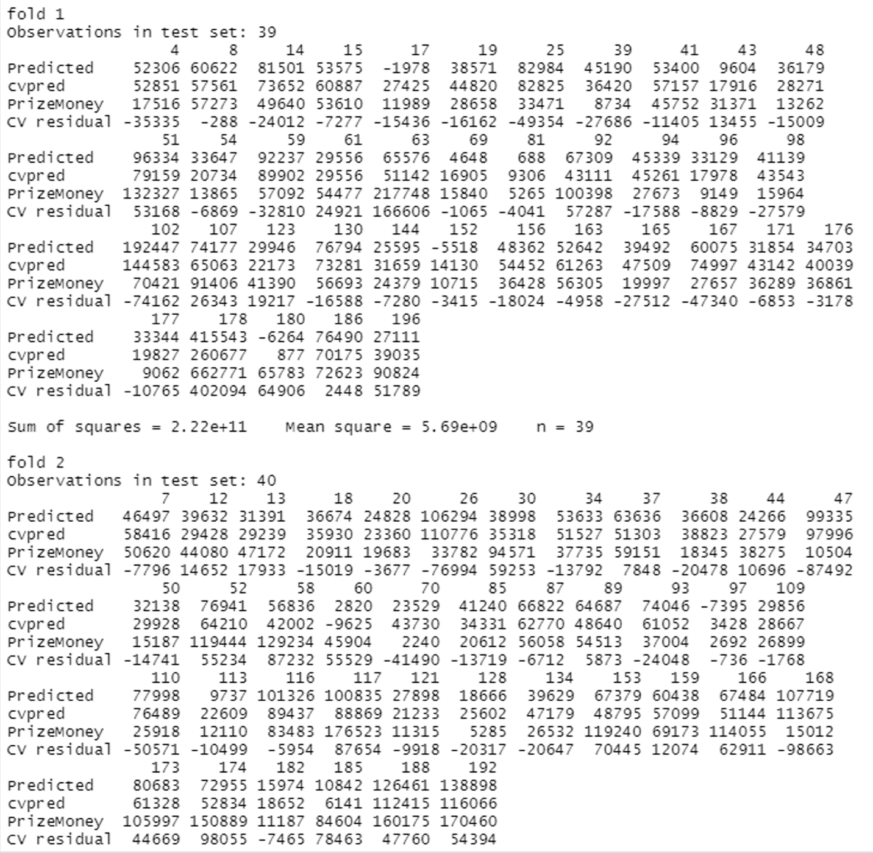

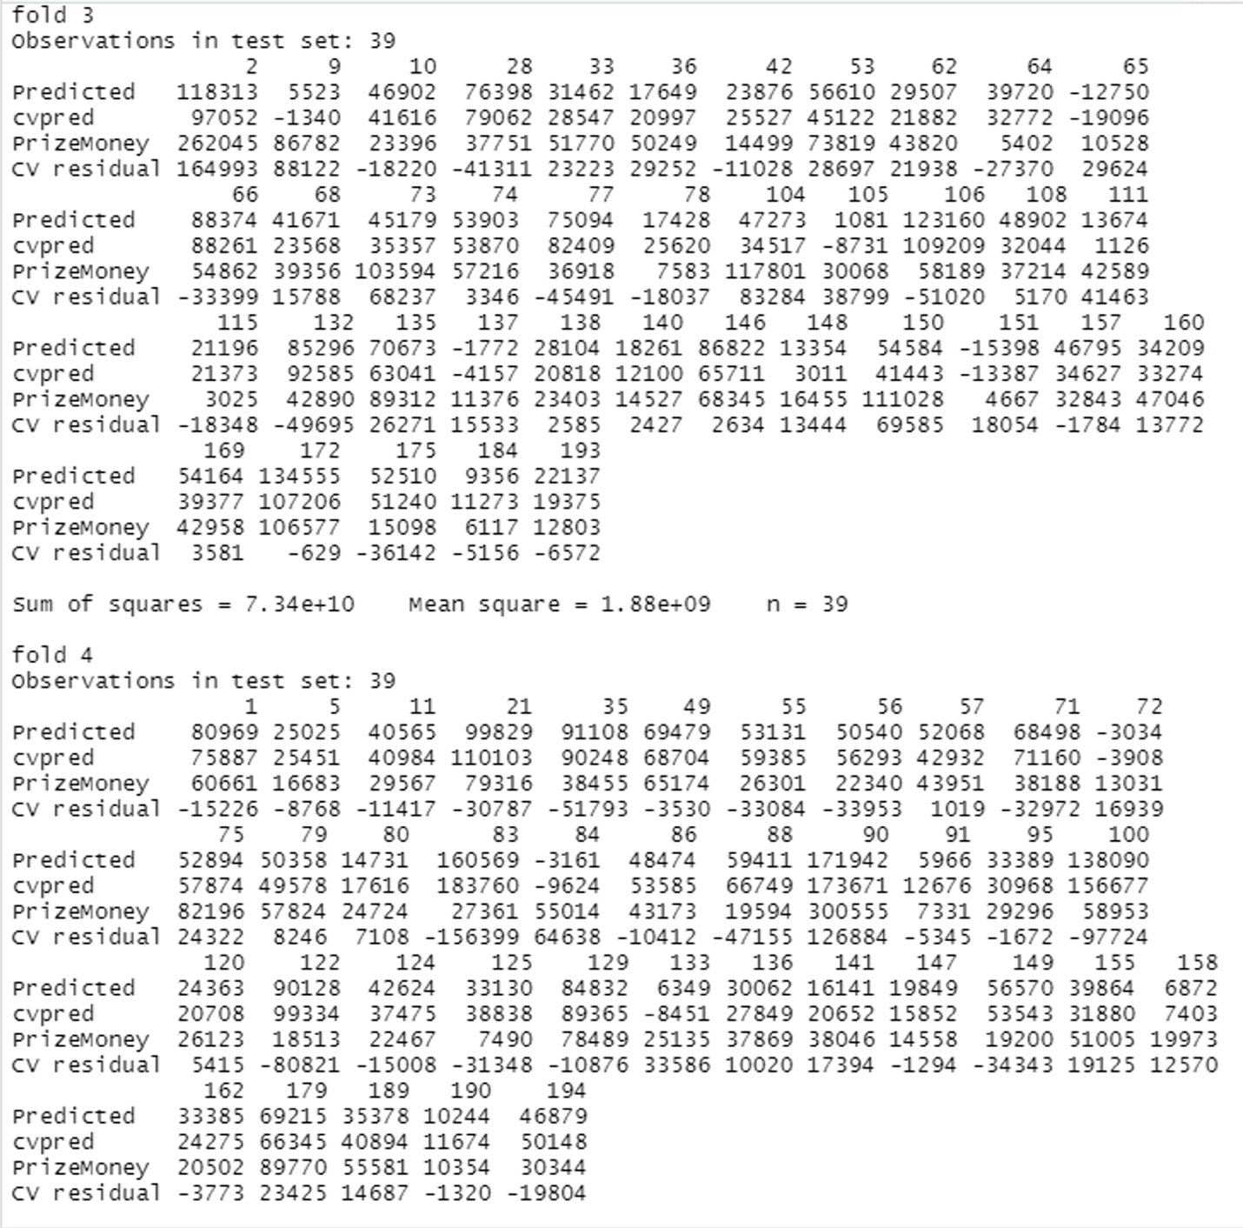

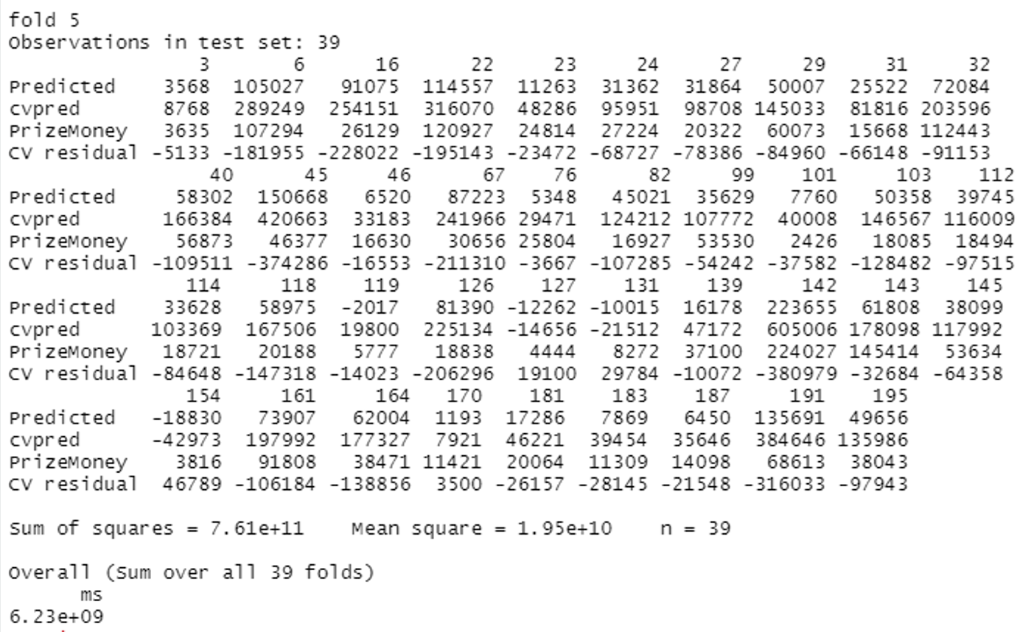

The average mean square error for 5-fold cross-validation after adding BirdieConversionSQ is **6.23e+09**

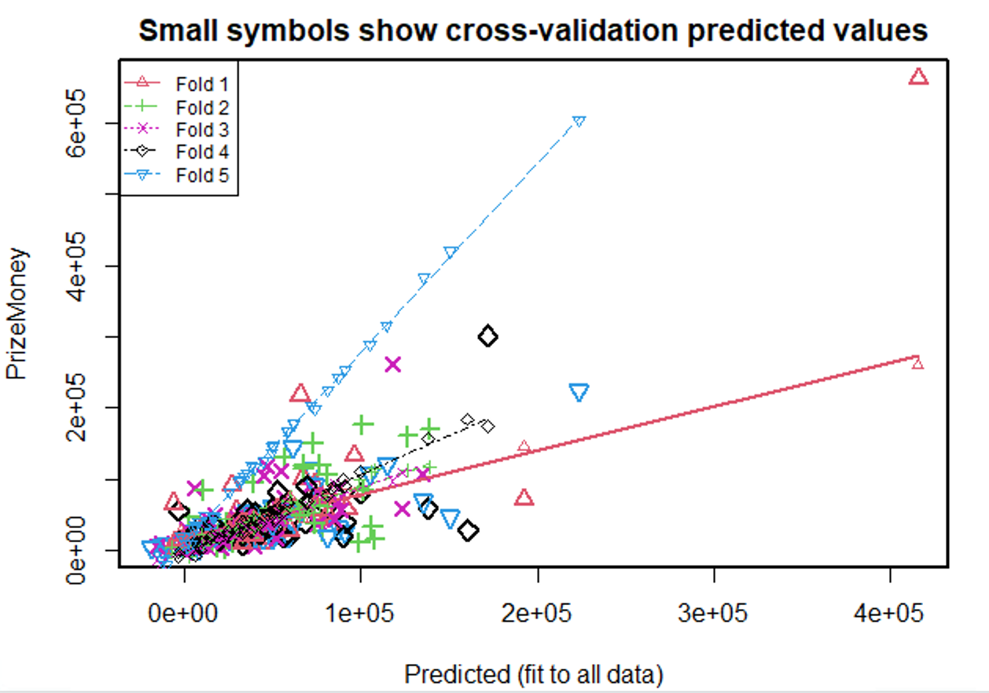

Adding **GIRSQ, BirdieConversionSQ, and bouncebackSQ to** our model and evaluating **5-fold cross-validation**

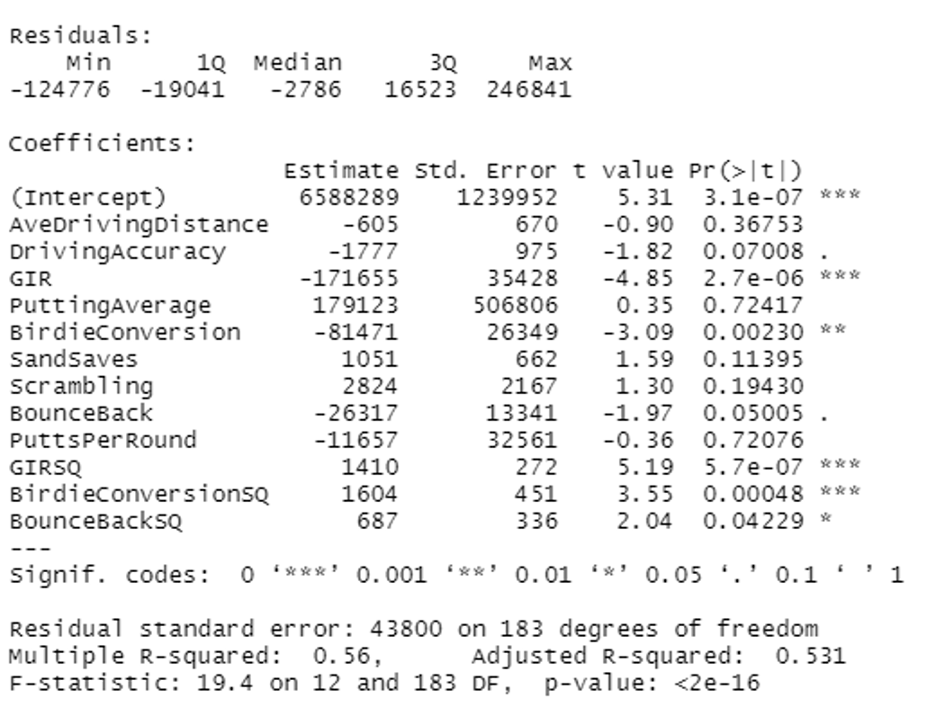

After adding **BounceBackSQ,** F-test has a very low P-value, this means that we reject the null hypothesis i.e. (all the Betas are equal to zero) and accept the alternative hypothesis that at least one is not equal to zero.

For Gir, birdie conversion, GIRSQ, BirdieconversionSQ, and BounceBackSQ we reject the null hypothesis and accept the alternative hypothesis, they all lie under the significance value of 0.05. The adjusted R-squared is 0.531 which means 53.1% variability in y is explained by our model.

**Now,5-fold cross-validation after adding bouncebackSQ**

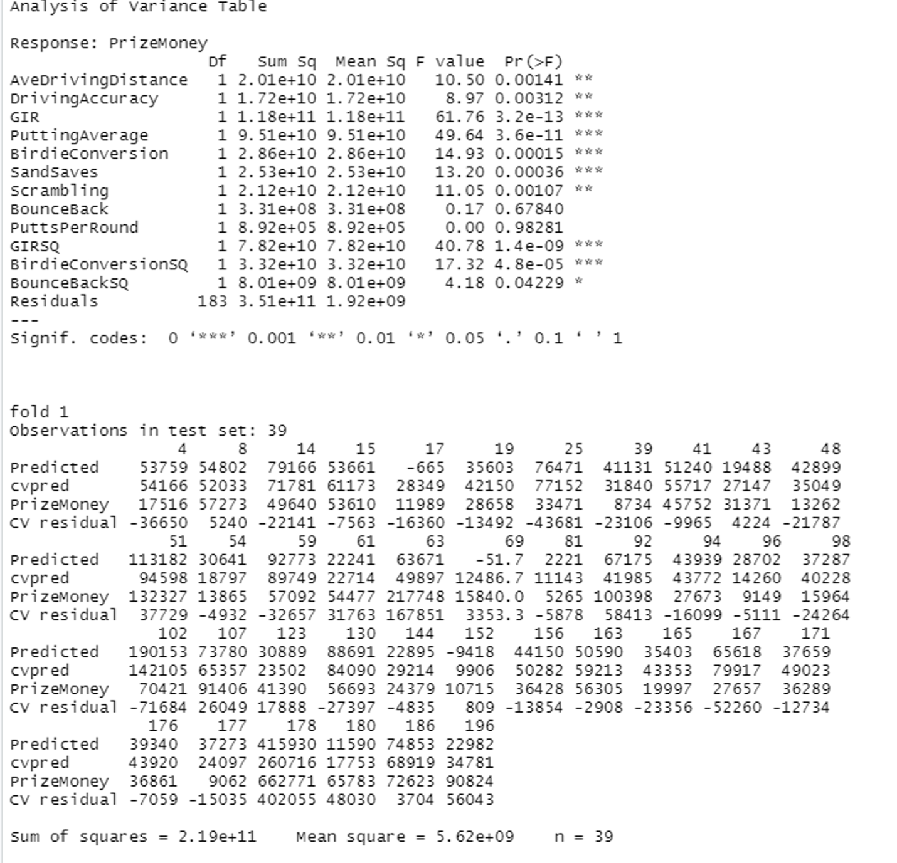

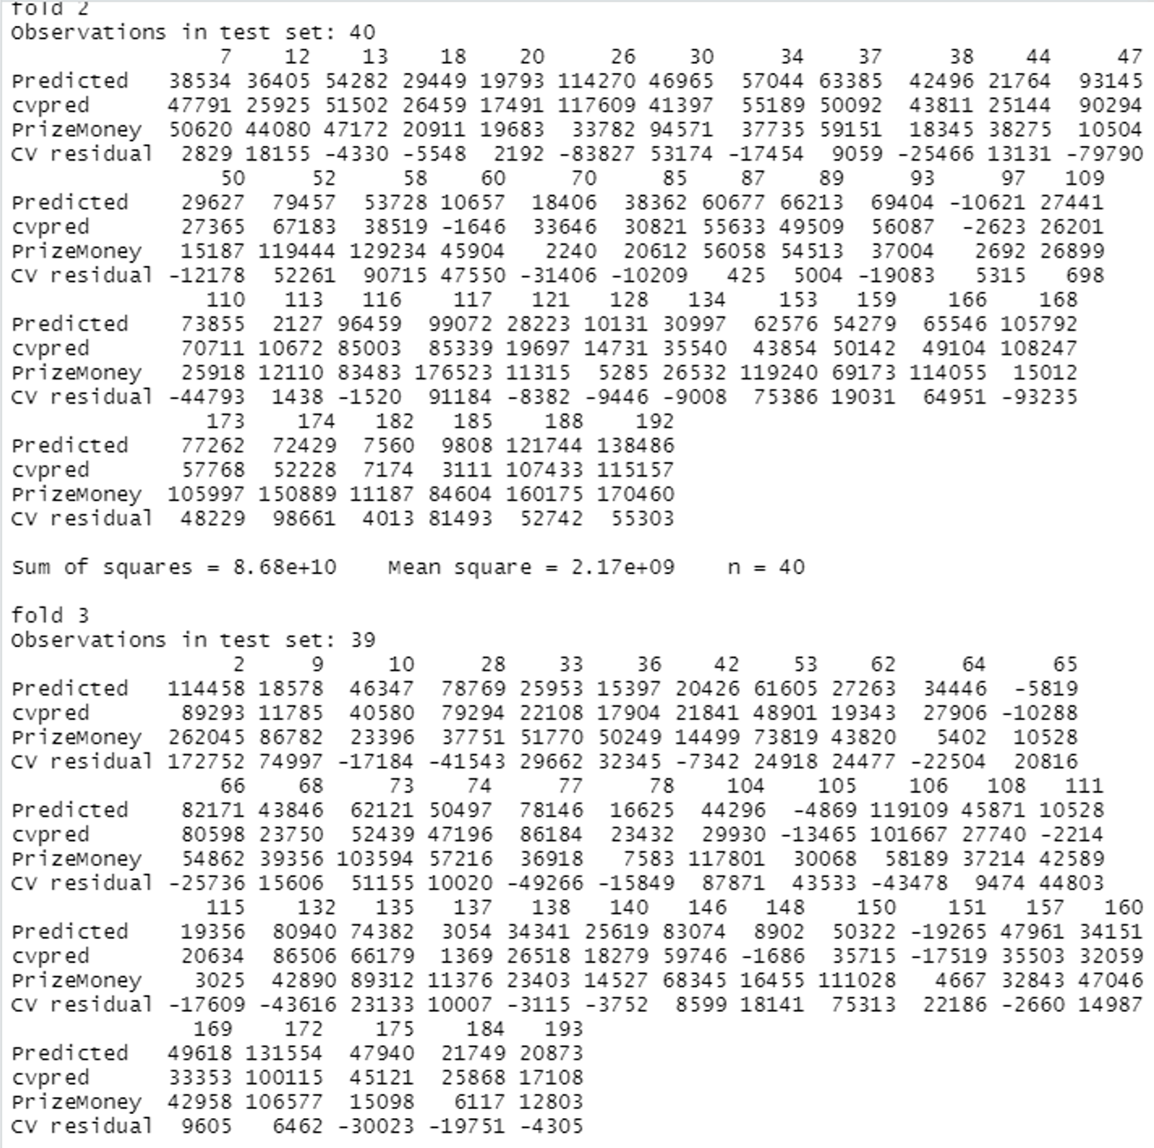

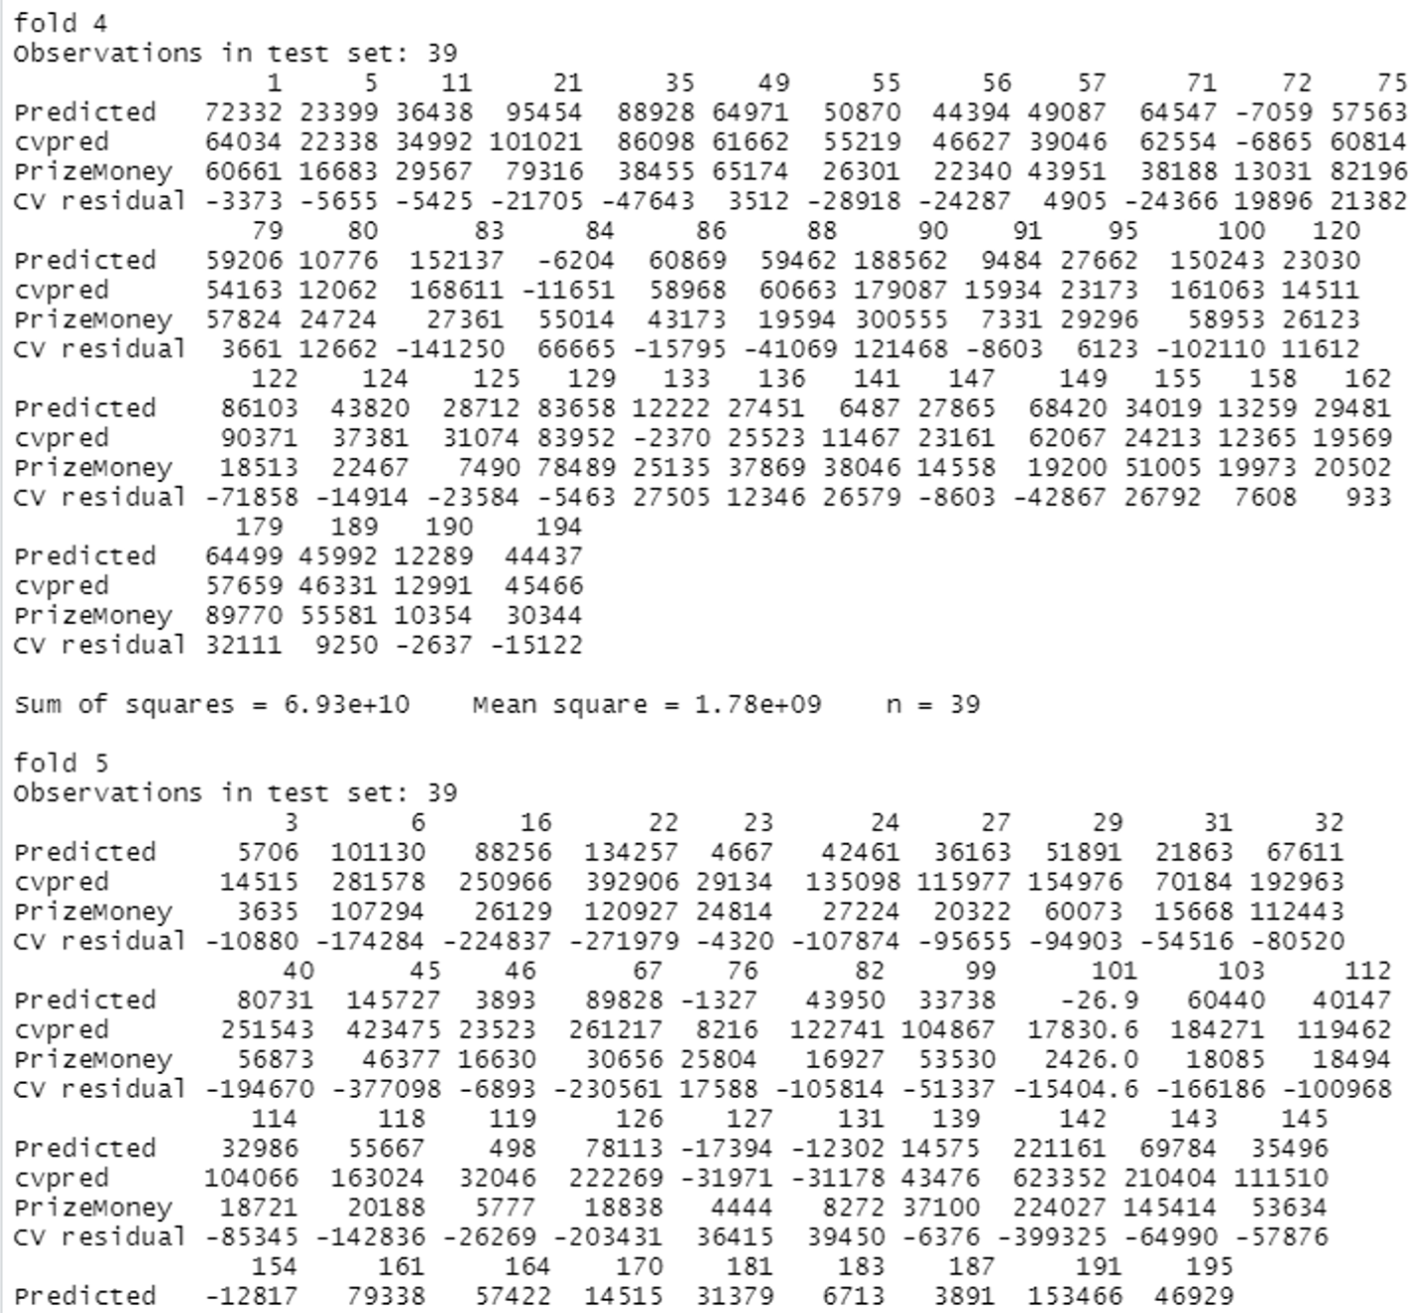

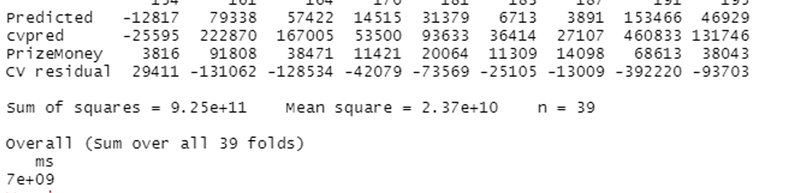

The average mean square error for 5-fold cross-validation after adding bouncebackSQ is **7e+09**

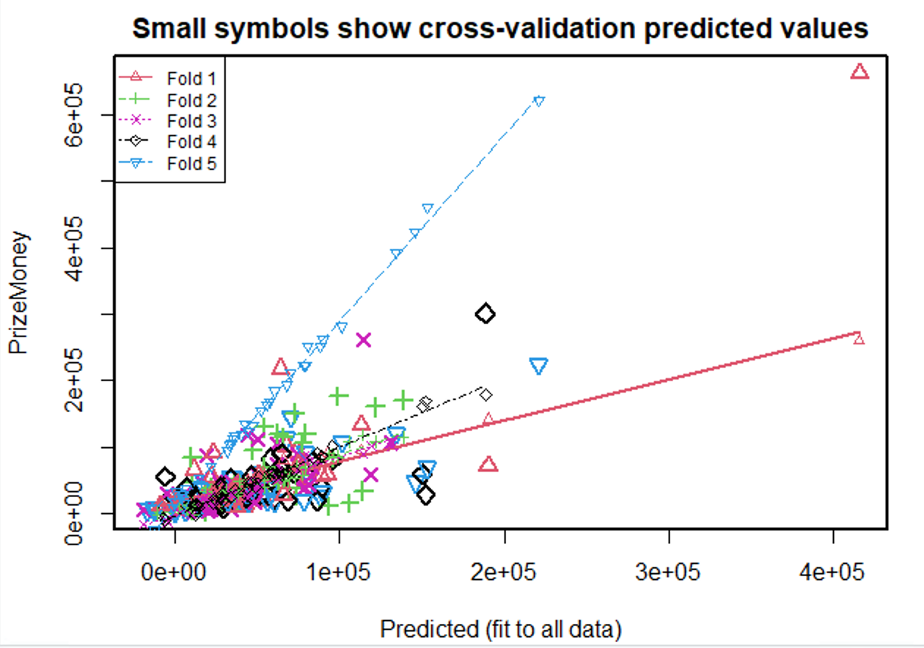

1. **The second-order model is**

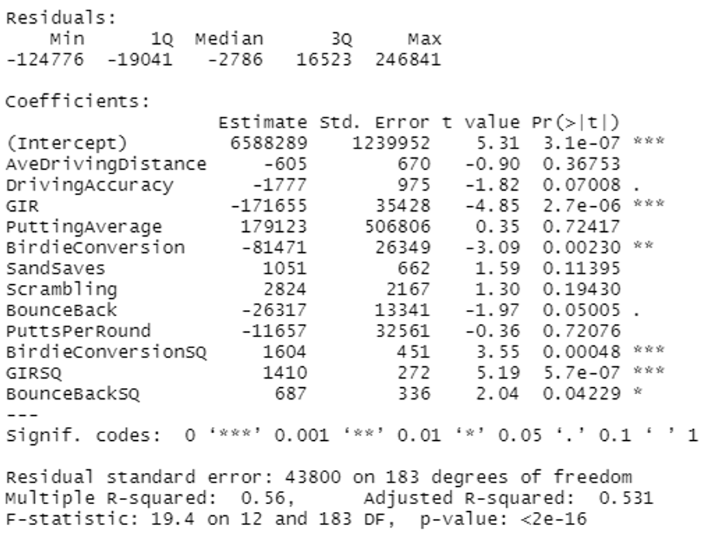

F-test has a very low P-value, this means that we reject the null hypothesis i.e. (all the Betas are equal to zero) and accept the alternative hypothesis that at least one is not equal to zero.

For Gir, birdie conversion, GIRSQ, BirdieconversionSQ, and BounceBackSQ we reject the null hypothesis and accept the alternative hypothesis, they all lie under the significance value of 0.05. The adjusted R-squared is 0.531 which means 53.1% variability in y is explained by our model.

Model using **backward selection**.

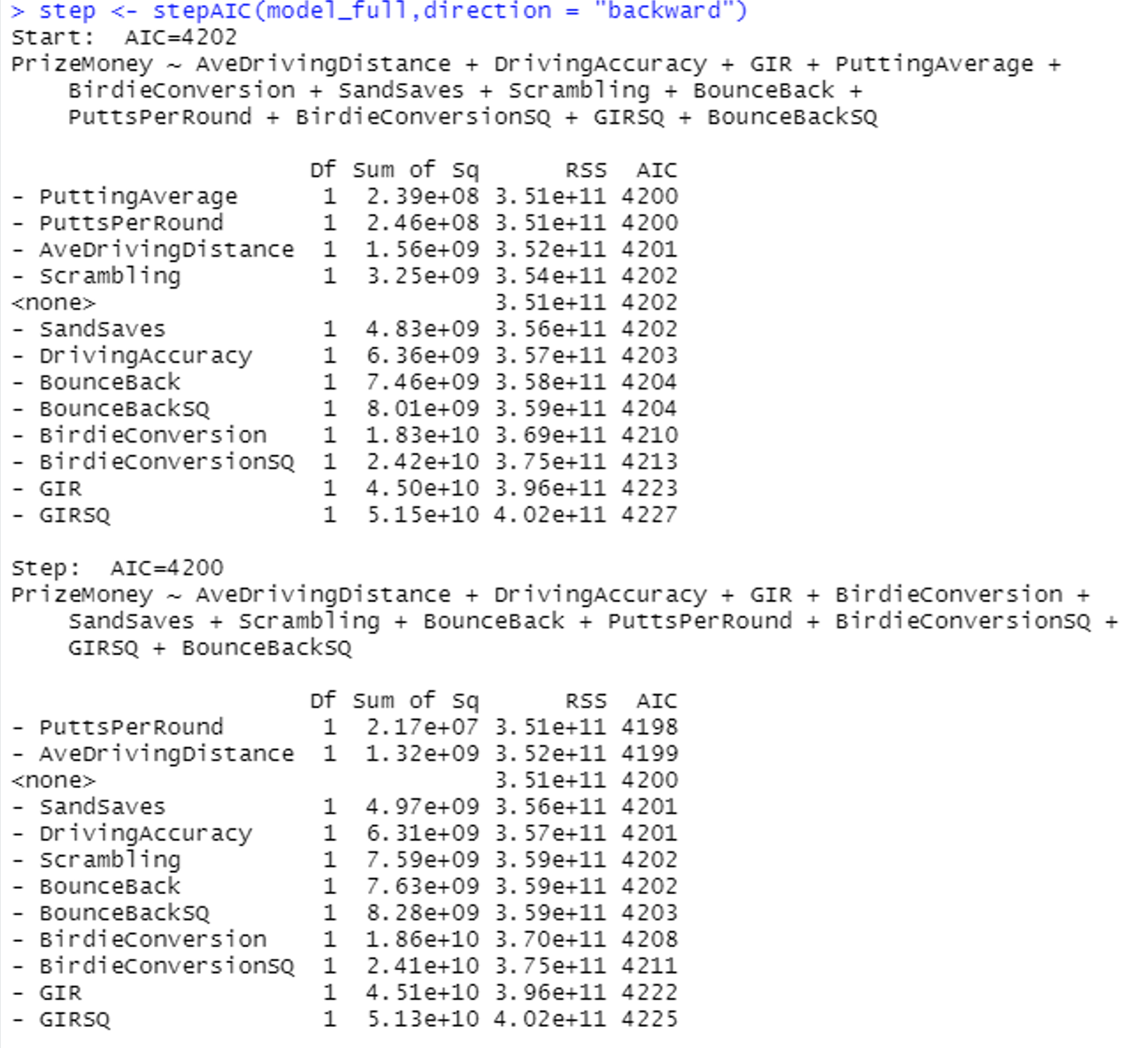

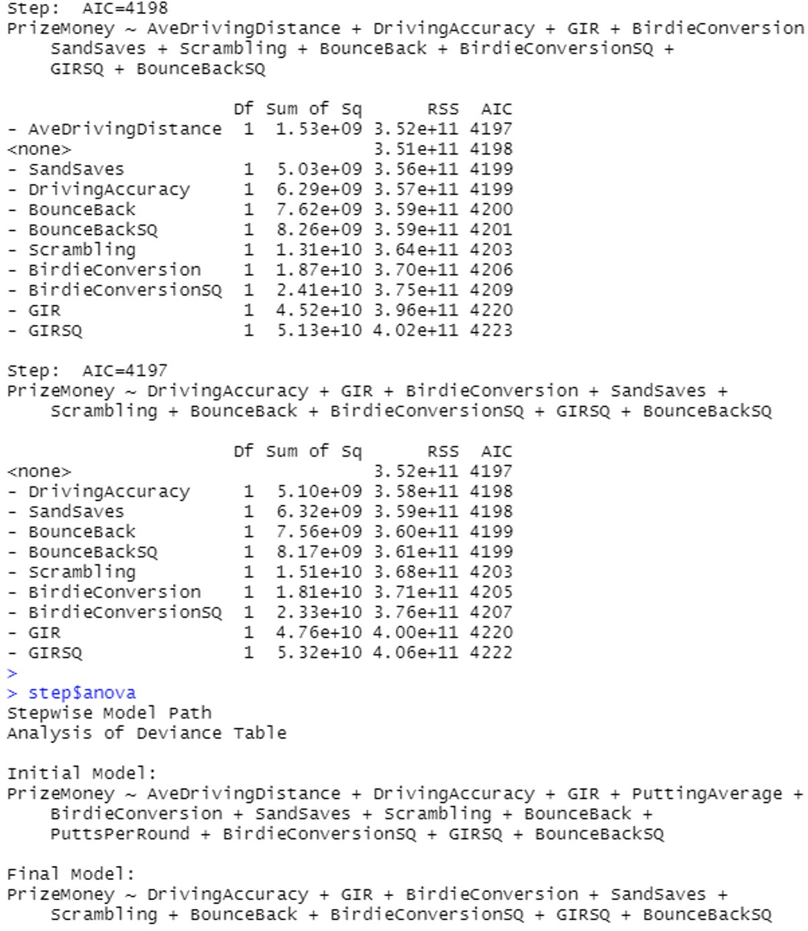

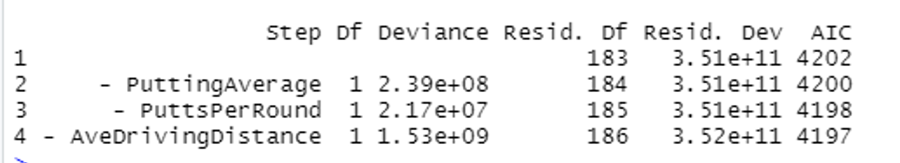

Evaluating **5-fold cross-validation** on second-order model

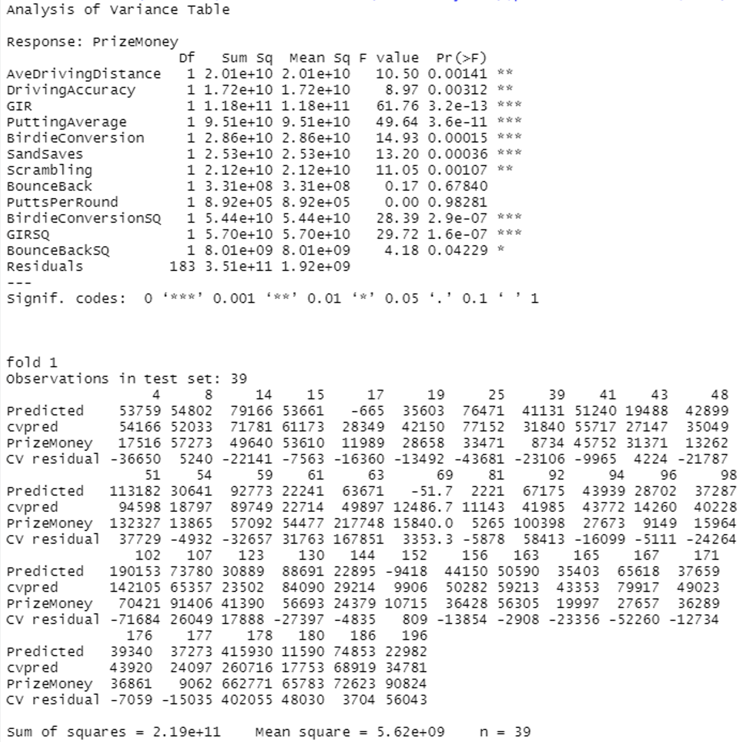

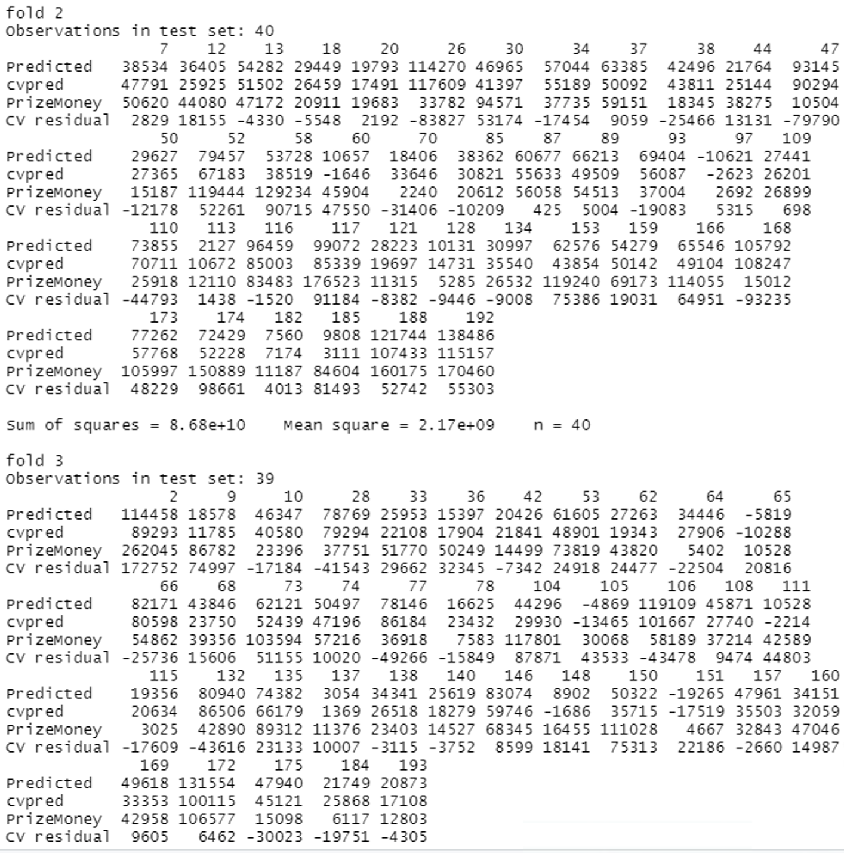

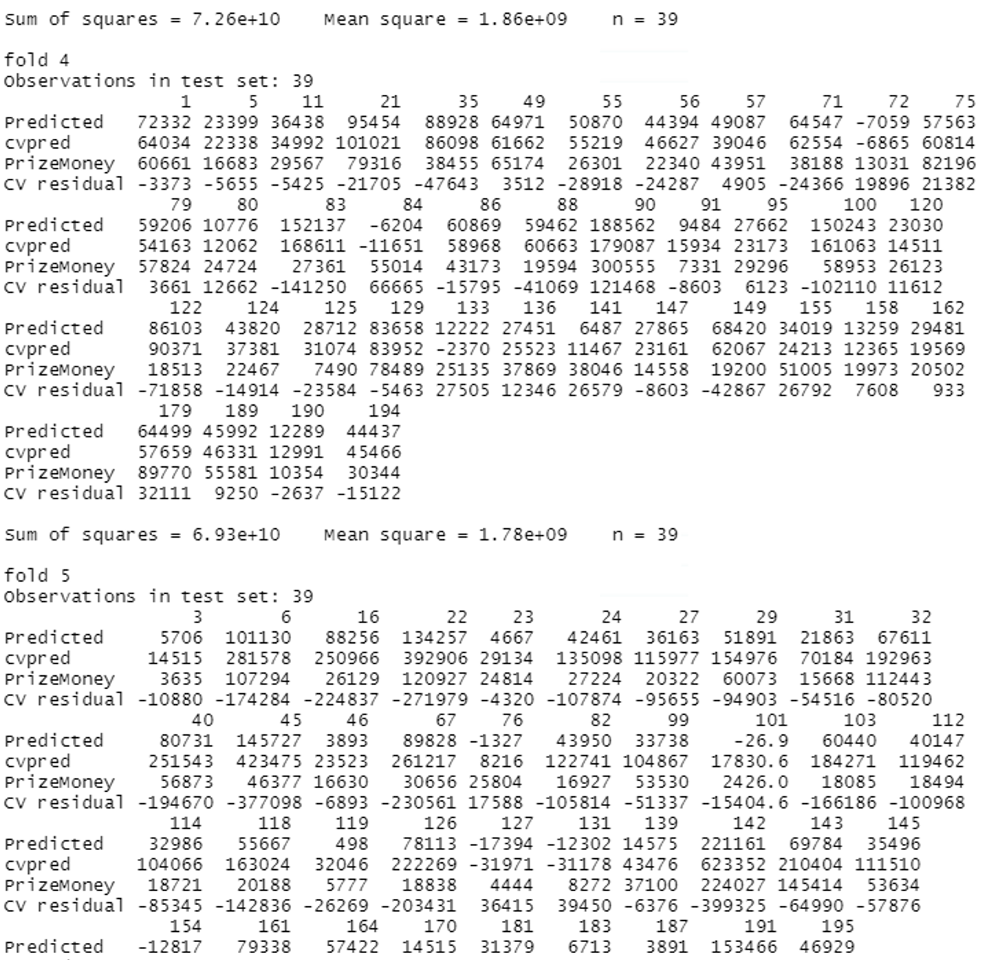

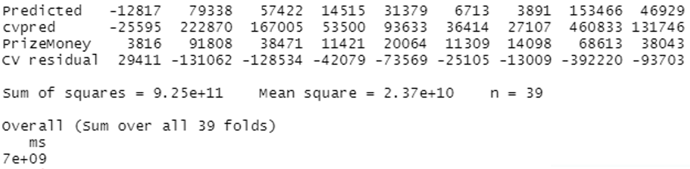

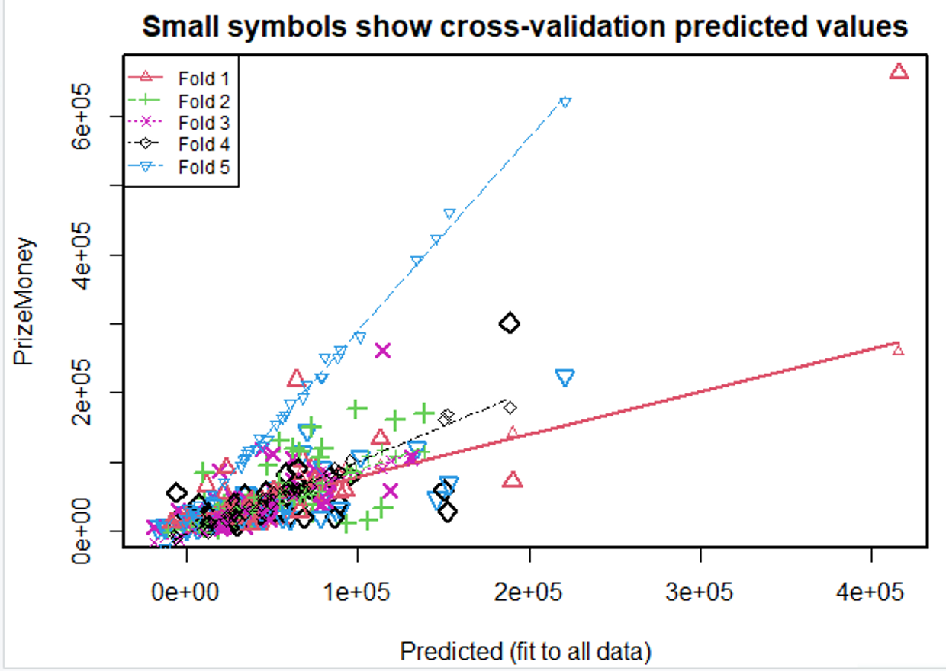

Overall mean square error is 7e+09

Yes, we arrived at the same model as in part(b) because both models satisfy the F-test whereas Gir, birdie conversion, GIRSQ, BirdieconversionSQ, and BounceBackSQ has a value under 0.05.

By, using 5-fold cross-validation we get the same average mean square error as in part(b).

1. Both methods have their pro and corn. Using scatter plots to determine a second-order model is a good approach. Looking at the scatter plot will give you an idea about the relationship between the independent and dependent variables. Looking at the curve in the scatter plot can tell us about the second-order term, but it has drawbacks, if we fail to interpret the scatter plot, it will give us false results

The benefit of trying all the second-order terms is that you will find which term works well for you and which does not, but the major drawback is that you need to check for all datasets, which is not feasible for large datasets.

I think looking at the scatter plot is the best case because just by eyeballing we can infer the second-order term, but we need to be good at interpreting the scatter plot.